**Thesis Title - Times New Roman, Bold, 16 font size, Single line Spacing, Please Do NOT change the format or style**

**Author\***

1Department of XXXXXXX, National Institute of Technology, Warangal, Telangana State-506004, India.

*e-mail: ----------@--------

**Introduction OR Motivation OR Objectives of the thesis:** Times New Roman font, size 12 and with single line spacing only. This part should include brief the motivation/objectives of your thesis. **Limit for Ph.D summary or synopsis of the thesis is maximum 2 pages only.**

# Points to consider while preparing your brief thesis summary

Well prepared summary enables reduce unnecessary work in the review process. The following points summarize the key issues you need to comply with when preparing your summary.

* **Check your article file It is not uncommon for errors to appear, it is absolutely essential to very carefully check your article file before submitting.**
* **Do not add page numbers or headers/footers**. Our article templates **deliberately** do not include these, so please do not add them.
* **Do not alter the margins of our templates**.
* **Prepare and format references with care**. Please prepare and **format** your references in accordance with the examples supplied with the author templates and documentation.
* **Use clear, legible graphics and diagrams**. It will help the reviewers to analyze your article properly and to make an appropriate decision about the selection of your thesis for the Ph. D thesis award presentation.

## Key Results of your research: Include the relevant and important content briefly – Only the gist of your thesis work shall be given in an impressive manner

## Formatting and Inserting Equations if any

Limited Equations if any should be centered with equation numbers on the right-hand side (flush right) as shown below,

 (1)

## Figures

Figures, tables, and equations must be inserted in the text and may not be grouped. If you need to arrange a number of figures, a good tip is to place them in a table, which gives you additional control of the layout. Leave a line space between your figure and any text above it, like this one:

Cite all figures in the text consecutively. The word “Figure” should be spelled out if it is the first word of the sentence and abbreviated as “**Fig.**” elsewhere in the text. Place the figures as close as possible to their first mention in the text at the top or bottom of the page with the figure caption positioned below. Figures must be inserted in the text and may not follow the Reference section. Set figure captions in 11 point size, Times Roman font. Type the word “**Fig. 1**.” in bold uppercase, followed by a period.

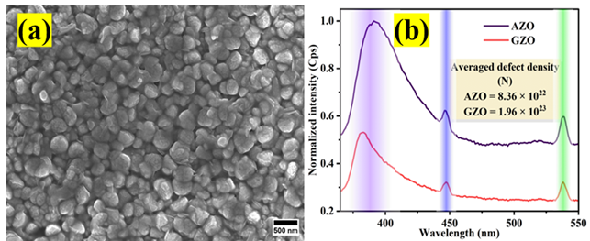

**Fig. 1. (a)** FESEM micrograph of X doped MNX, and **(b)** Photoluminescence emission spectra of the sample

|  |  |  |
| --- | --- | --- |
| “**Table 1,**” which labels the caption, should be bold and first letter is capitalized. Center this text above the Table. Tables should have top and bottom rules, and a rule separating the column heads from the rest of the table only. | | |
| **Column Header Goes Here** | **Column Header Goes Here** | **Column Header Goes Here** |
| Row Name Here | x | x |
| Row Name Here | x | x |

**Conclusion:** Include a very brief conclusion of your thesis work.

# References (If necessary only you can include 1 or 2)

1. M. P. Brown and K. Austin, *The New Physique* (Publisher Name, 2005), pp. 25–30.
2. M. P. Brown and K. Austin, Appl. Phys. Letters **85**, 2503–2504 (2004).
3. R. T. Wang, “Title of Chapter,” in *Classic Physiques*, edited by R. B. Hamil (Publisher Name, Publisher City, 1999), pp. 212–213. (Can use et al., if there are more than two authors

**(NOTE: Your List of Publication and Patents if any shall not be included here, they should be submitted as a separate merged file)**