(*IEMDST-2024, NIT-Warangal*)

**Times New Roman, Bold, 16 font size, Single line Spacing, Please Do NOT change the format or style**

Author1, Author 1, Author 1*, Author 2 **(Please bold and underline the presenting author)**

1Department of Physics, National Institute of Technology, Warangal, Telangana State-506004, India.

2Department of ---------, ---------- Institute of Science and Technology, ------, State-XXXX, India.

*Corresponding author e-mail: ----------@--------

**Abstract**

Please use Times New Roman font, size 12 and with single line spacing only. ***The abstract should NOT exceed one page*** including, the abstract content, one or two images within the page setting and references [1]. Please do not adjust the gutter settings [2].

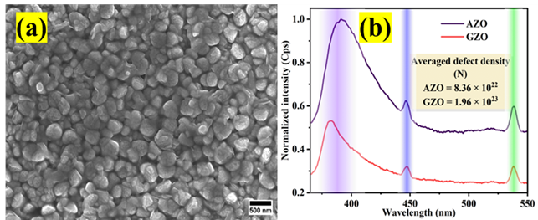

Fig. 1. (a) FESEM micrograph of X doped MNX, and (b) Photoluminescence emission spectra of the sample

**References**

[1] D. Aryanto, E. Hastuti, M. Taspika, K. Anam, I. Isnaeni, W.B. Widayatno, A.S. Wismogroho, P. Marwoto, B.W. Nuryadin, A. Noviyanto, and S. Sugianto, J. Sol-Gel Sci. Technol. 96 (2020) 226–235.

[2] C. Hariharan, Appl. Catal. A Gen. 304 (2006) 55–61.